IAMT
Recipe Book 2020

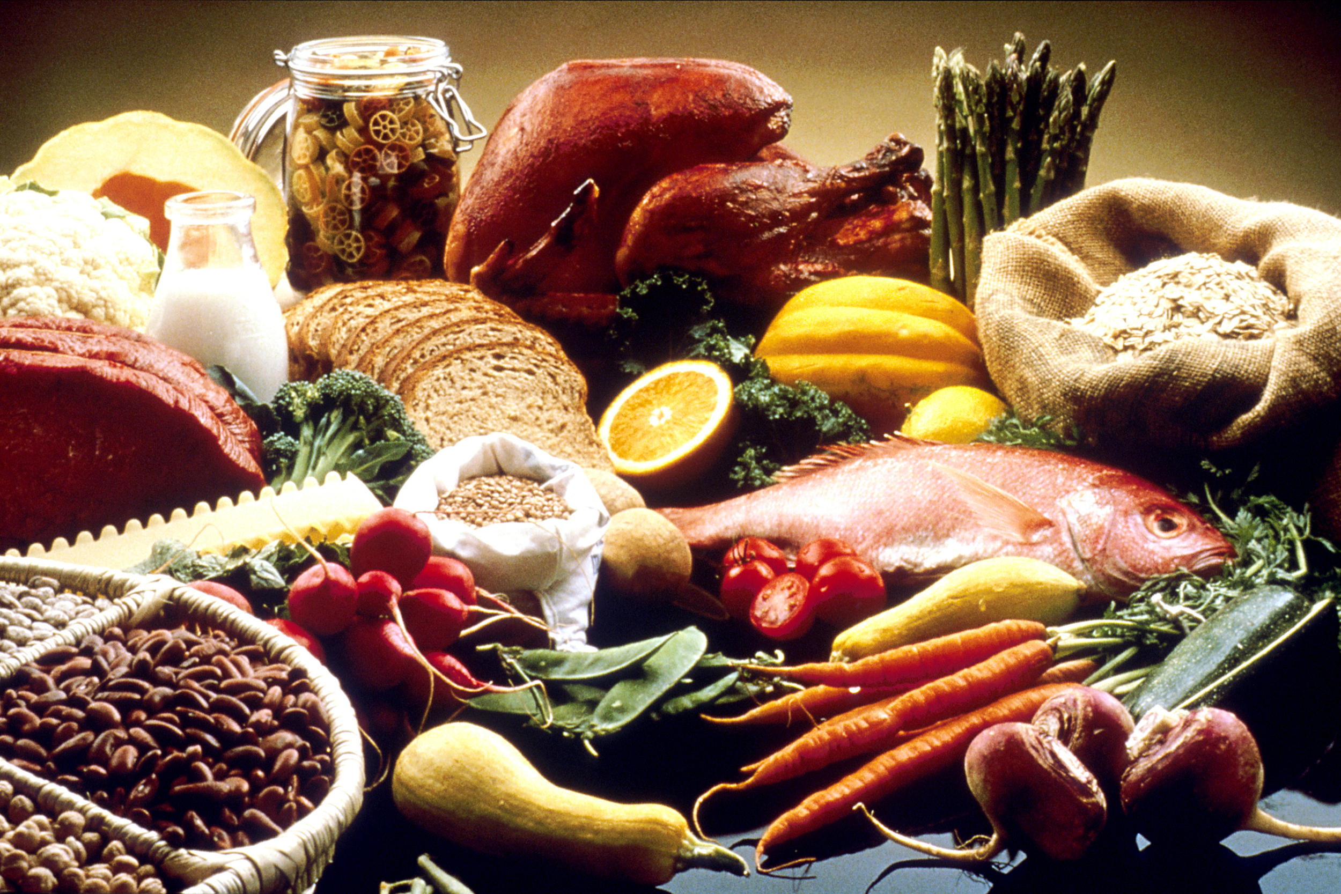

Table of contents

- Salads
  - Chickpea Sunflower Salad
  - Orzo Salad
- Soups
  - Smoky Vegetarian Split Pea Soup
- Mains
  - Vegetarian Rajma Curry
  - Vegan Stuffed Jumbo Shells
  - Mediteranian Shrimp Kabobs
  - Cream of Pesto Pasta
- Desserts
  - Flourless Chocolate Zucchini Brownies
  - Blueberry Sour Cream Pie

Chickpea Sunflower Salad (Vegan, Gluten Free)
Submitted by: Ava Marvin

One of my favorite pic-nic foods! Put it in lettuce cups, scoop with crackers, have on a sandwich, or just eat as a side! It is a great “tuna” or “chicken” salad replacement too - enjoy!

Ingredients:

- 1 15- ounce can chickpeas (rinsed and drained) (or make from dried chickpeas, I usually do a cup of dried and boil)
- 1/4 cup roasted unsalted sunflower seeds (if salted, scale back on added salt)
- 3 Tbsp vegan mayo (sub tahini for a more earthy, nutty flavor)
- 1/2 tsp dijon or spicy mustard (if using tahini instead of mayo, use half as much mustard)
- 1 Tbsp maple syrup (or sub agave or honey if not vegan)
- 1/4 cup chopped red onion
- 2 Tbsp fresh dill* (finely chopped) (dried dill works great too!)
- 1 healthy pinch each salt and pepper (to taste)
- Sliced avocado, onion, tomato, and or lettuce (optional // for serving)

Instructions
- Add chickpeas to a mixing bowl and lightly mash with a fork for texture. Then add sunflower seeds, mayo, mustard, maple syrup, red onion, dill, salt, and pepper and mix with a spoon. Taste and adjust seasonings as needed.
- Scoop a healthy amount of filling onto two of the pieces of bread, add desired toppings and sauce, and top with other two slices of bread.
- Sunflower-chickpea mixture will keep covered in the fridge for up to a few days, making it great for quick weekday lunches!

https://minimalistbaker.com/chickpea-sunflower-sandwich/

Orzo Salad with Cranberries, Apples, and Herbs (vegan)
Submitted by: Molly Robitaille

Ingredients:
Orzo:
- 2 tablespoons olive oil
- 2 cups Orzo (or Israeli couscous)
- 4 cups vegetable or chicken broth
- 1/4 cup chopped fresh flat-leaf parsley
- 1 1/2 tablespoons chopped fresh rosemary leaves
- 1 teaspoon chopped fresh thyme leaves
- 1 medium green apple, diced
- 1 cup dried cranberries
- 1/2 cup slivered almonds, toasted

Vinaigrette:
- 1/4 cup apple cider vinegar
- 2 tablespoons maple syrup
- 1 tablespoon kosher salt
- 1/2 teaspoon freshly ground black pepper
- 1/4 cup olive oil

Instructions:

For the orzo: In a medium saucepan, heat the olive oil on medium-high heat. Add the orzo and cook, stirring occasionally until slightly browned and aromatic, about 3 to 5 minutes. Add the broth and bring to a boil. Simmer for 10 to12 minutes or until the liquid has evaporated. Transfer the cooked couscous to a large bowl and set aside to cool. Add the parsley, rosemary, thyme, apple, dried cranberries, and almonds.

For the vinaigrette: In a small bowl, combine the vinegar, maple syrup, salt, and pepper. Whisk in the olive oil until smooth. Pour the vinaigrette over the orzo and toss to coat evenly. Serve cold. This recipe originally comes from Giada De Laurentiis, but it’s one of my family’s favorite summer salads.

Smoky Vegetarian Split Pea Soup
Submitted by: Victoria Storm

Healthy, hearty, and packed with smoky flavor...this vegetarian split pea soup is pure comfort in a bowl!
Course Soup
Cuisine American
Keyword healthy soup recipe, vegan soup recipe
Prep Time 15 minutes
Cook Time 1 hour 20 minutes
Total Time 1 hour 35 minutes
Servings 6
Calories 359 kcal
Author Alissa Saenz
Ingredients
- 2 tablespoons olive oil
- 1 medium onion, diced
- 2 medium carrots, diced
- 2 medium celery stalks, diced
- 3 garlic cloves, minced
- 2 teaspoons ground cumin
- 6 cups vegetable broth
- 1 pound dried split peas
- Hot water, as needed (I used about 1 cup)
- 2 teaspoons red wine vinegar
- 1/2 teaspoon liquid smoke, or to taste
- Salt and pepper, to taste

Instructions:
Stovetop Method
- Coat the bottom of a large pot with oil and place it over medium heat.
- Give the oil a minute to heat up, then add the onion, carrot and celery.
- Sweat the vegetables for about 10 minutes, until they soften up a bit.
- Add the garlic and cumin, and cook them with the vegetables until the garlic becomes very fragrant, about 1 minute.
- Stir in the broth and peas. Raise the heat and bring the liquid to a boil.
- Lower the heat and allow the soup to simmer until the peas are very soft and falling apart, about 1 hour to 1 hour and 15 minutes. Keep a bowl of hot water near the stove and add it as the broth dries up.
- When the soup has finished simmering, remove it from the heat and stir in the vinegar and liquid smoke. Season the soup with salt and pepper to taste.
- Ladle into bowls and serve.
Instant Pot Method
- Press the "sauté" button on your Instant Pot then add the oil.
- Give the oil a minute to heat up, then add the onion, carrot and celery.
- Sweat the vegetables for about 5 minutes, until they begin to soften up.
- Add the garlic and cumin, and cook them with the vegetables until the garlic becomes very fragrant, about 1 minute. Hit the "cancel" button.
- Stir in the broth and peas.
- Place the lid on your Instant Pot and set the valve to the "sealing" position. Press the "pressure cook" or "manual" button and set the pressure to high. Set the soup to cook for 15 minutes.
- When the soup has finished cooking, carefully move the valve to the "venting" position. Let the pressure release completely.
- Remove the lid from the Instant Pot. Stir in the vinegar and liquid smoke. Season the soup with salt and pepper to taste.
- Ladle into bowls and serve.

Enjoy!

Rajma (Red Bean) Curry (vegetarian) (fast)
Submitted by: Deb Soszko

Ingredients:
- 2-3 T olive oil
- 2 T minced, fresh ginger
- 1 medium onion, finely chopped
- 1 tomato, diced
- 3 cloves garlic, chopped
- 1 green chili, chopped (or ½-1 jalapeno, or you can skip it if you don’t like it spicy)
- 1 tsp salt
- 1 tsp ground cumin
- 1 tsp ground coriander
- ½ tsp whole cumin seeds (optional)
- ½ tsp ground turmeric
- ⅛-¼ tsp cayenne
- 2 (4 ounce) cans tomato sauce
- 2 (15 oz) cans cooked red kidney beans
- ½ cup chopped fresh cilantro
Naan and/or rice (for serving)

Instructions:
- Heat the oil in a large saucepan and saute the onion until translucent. Add the ginger, garlic, and green chili and saute for another 2 minutes.
- Add tomato sauce as well as all the spices; simmer for 5 minutes.
- Add the red kidney beans, 2 cups of water, and the chopped tomato. Bring to a simmer and let cook for 10 minutes. Garnish with cilantro and serve over rice and/or with toasted naan. A dollop of plain yogurt on top is delicious!

Vegan Stuffed Jumbo Shells
Submitted by: Cara Paden

Ingredients:
- 12-ounce package jumbo shells
- 26-ounce jar marinara sauce (about 3 cups)
- 14-ounce firm tofu
- 1/2 cup nutritional yeast
- 1/4 cup fresh lemon juice (about 1 large lemon)
- 1/4 cup water
- 1 1/2 teaspoons salt
- 2 teaspoons dried basil
- 2 teaspoons dried oregano
- 1 teaspoon garlic powder
- 10-ounce package chopped frozen spinach, thawed
- 1 pk Violife mozzarella cheese

Instructions:
- Preheat oven to 350
- Boil pasta, drain, and set aside
- Drain tofu and press dry with paper towels. Mix the tofu in bowl with a fork until the consistency looks like ricotta cheese
- Add nutritional yeast, lemon juice, water, salt, basil, oregano, and garlic powder to tofu. Do not over mix.
- After spinach has thawed a bit, mix it in with the other ingredients.
- In casserole dish, spread about 1 cup of marinara sauce evenly on the bottom
- Scoop about 2 tablespoons of ricotta mixture into each shell and place in the casserole dish.
- When the dish is filled, pour the rest of the sauce on top.
- Place in the oven for about 15-20 min.
- Take out of sprinkle mozzarella cheese on top and put back in over for another 5-10 min or until cheese is melted.

Mediteranian Shrimp Kabobs
Submitted by: Nancy Swanson
From website: https://www.themediterraneandish.com/
Ingredients:
For the Marinade
- 1/3 cup EVOO
- Zest of 2 lemons
- 4 garlic cloves minced
- ¼ cup packed chopped fresh parsley
- 1 teaspoon oregano
- 1 teaspoon paprika
- ½ teaspoon coriander
- ½ teaspoon red pepper flakes
For the Shrimp
- 2 lb large shrimp peeled and deveined
- Kosher salt
Instructions:
- Combine the marinade ingredients in a small bowl. Reserve 2 tbsp of the marinade in a separate bowl for later.
- Pat the shrimp dry and season with kosher salt. Place the shrimp in a large bowl and pour the marinade all over. Toss to combine.
- Cover and refrigerate for 20 to 30 minutes (do not go longer).
- Thread the shrimp on skewers, about 4 large shrimp per skewer. (If using bamboo skewers they need to be soaked in water for at least 30 minutes first).
- To grill on an outdoor gas grill. Preheat a gas grill to high. Then, reduce heat to low (temperature should be somewhere between 275 to 325ºF). Carefully grease the cooking grates. Once the grill reaches the recommended temperature, add the shrimp skewers and close the lid. Cook shrimp for 2 to 3 minutes on each side or until no longer translucent.
- To grill on an indoor griddle or cast iron grill. Heat a dry griddle over medium-high heat until hot but not smoking. Add the shrimp skewers and cook on one side about 3 or 4 minutes. Turn shrimp over and cook another 2 to 3 minutes.
- Transfer the grilled shrimp skewers to platter and spoon the remaining marinade your reserved earlier over the grilled shrimp skewers. Add a splash of lemon juice. Serve immediately.

Cream of Pesto Pasta with Asparagus & Corn
Submitted by: Meredith Powers

Serves 2 (but I double it)

Ingredients:
- ¼ tsp. Salt
- 4 tbsp. Butter
- 1 fresh ear of corn, husk and remove kernels with a sharp knife. Discard cob
- 10 spears of asparagus, discard bottom quarter of spears and cut remainder into 1” pieces
- 2 garlic cloves, minced
- 1 large fresh or dried hot pepper, finely diced or crushed
- 2 servings of fresh Angel hair egg pasta (approx. 4 oz/serving)
- ½ c whipping cream
- 4 tbsp (3 oz) fresh pesto sauce or double this at your preference
- ⅓ cup grated parmesan cheese
- ½ tsp. Fresh ground black pepper

Instructions:
- In a large pot, bring 6 cups of salted water to a boil.
- 2. In a saute pan, over med-high heat, melt 2 tbsp butter. Saute asparagus, corn, garlic, and hot pepper for about 5 minutes until corn kernels begin to brown. Reserve in a warmed bowl. Save pan for step 4.
- Add pasta to boiling water and cook according to directions.
- In the same saute pan, over low heat, melt remaining 2 tbsp. Butter and slowly stir in cream, parmesan (save a pinch for the garnish), pesto, and black pepper. Stir and allow to simmer over lowest heat for 2 minutes.
- Drain pasta.
- Add pasta to pesto cream sauce (already in pan). Toss.
- Serve on warmed plates or bowls. Top with asparagus and corn.

Garnish with a basil leaf and sprinkle of parmesan.
Great with fresh, crusty bread.

Flourless Chocolate Zucchini Brownies
Submitted by: Allison Gunnink

Ingredients:

- 2 large egg whites
- 1c finely ground almond meal or almond flour
- 1/2c unsweetened cocoa powder
- 1tsp baking soda
- 1tsp vanilla extract
- 1/4tsp salt
- 1/2c pure maple syrup or raw honey
- 2/3c grated zucchini, not squeezed
- 3/4c semisweet chocolate chips

Instructions:
- Preheat the oven to 325°F. Prepare a nonstick 9 x 9 inch baking pan with cooking spray. Cut a sheet of parchment paper about 9 inches wide, and long enough to form a sling so you can easily remove the brownies once cooked. Place into the baking pan.
- In a medium bowl, whisk the egg whites.
- In a large bowl, whisk together the almond flour, cocoa powder, salt, and baking soda. Add the zucchini and egg whites and stir with a spatula. Add the honey and vanilla and stir with the spatula until combined. Fold in the chocolate chips. Pour the batter into the prepared baking pan.
- Bake until a toothpick inserted into the center comes out clean, about 30 minutes. Let cool about 30 minutes. Cut into 12 squares and serve.
Notes
From https://www.skinnytaste.com/zucchini-brownies/

Usually needs considerably more than 30 minutes to cook

Blueberry Sour Cream Pie
Submitted by: Beth Blankenship

Ingredients:
Shortbread
- 1 cup butter (softened)
- ½ cup sugar
- 2 cup flour

Filling
- 1 cup sugar
- ½ cup flour
- ½ tsp salt
- 2 eggs
- ½ cup sour cream
- 3 cup fresh fruit of choice (blueberries used for this recipe 🙂)

Streusel
- ½ cup sugar
- ½ cup flour
- ¼ cup butter

Instructions:
- Whip butter and sugar for shortbread until fluffy. Mix in flour and spread into greased pie pan.
- Pour fruit into prepared pan. Mix together remaining filling ingredients and pour over fruit.
- Blitz streusel ingredients in food processor and spread evenly over pie filling.
- Bake at 350 for 50-60 minutes.

